Xiaoting Lian

CISC3140

Lab 10

For this lab, I choose to create css stylesheet for lab 8, what I did in lab 8 is a calculator.

This is how the calculator looks without CSS file.

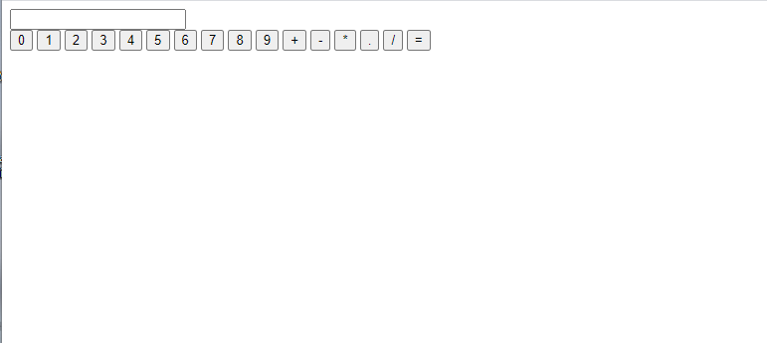

This is how it looks when I link the html with CSS.

